Engineering Appendix: End-to-End Execution & Verification Records
This appendix documents three complete real-world execution runs within the AI Workforce Multi-Agent Architecture of Electro-Tech Representatives Ltd. The documentation provides verified evidence across all system pathways, including n8n canvas logs, Gmail notifications, and Google Sheets ledger updates.

Scenario A: Purchase Order (PO) with Credit Exceeded + HITL Manager Approval
Complex Flow - Credit Violation & Manager Authorization Required
Input Payload Details:
* Customer: CUST-038 (Soroka Medical Center)
* Part Number: 9GA0312P3J001 | Quantity: 20,000 units
* Total Amount: 1,616,062.50 ILS ($448,906.25 USD) ← Exceeds approved credit limit of 85,000 ILS
* Synchronous Quote ID: Q-2026-1343 | Session ID: SESS-1767225234048
Execution Steps & Evidence Screenshots:
1. CRM Agent & Validation Guard (Credit Violation & HITL Trigger):
The CRM Agent detects a severe credit breach (1.6M ILS vs. 85K ILS available limit). The Validation Guard halts automated processing and triggers a real-time Human-in-the-Loop (HITL) email authorization request to executive management.
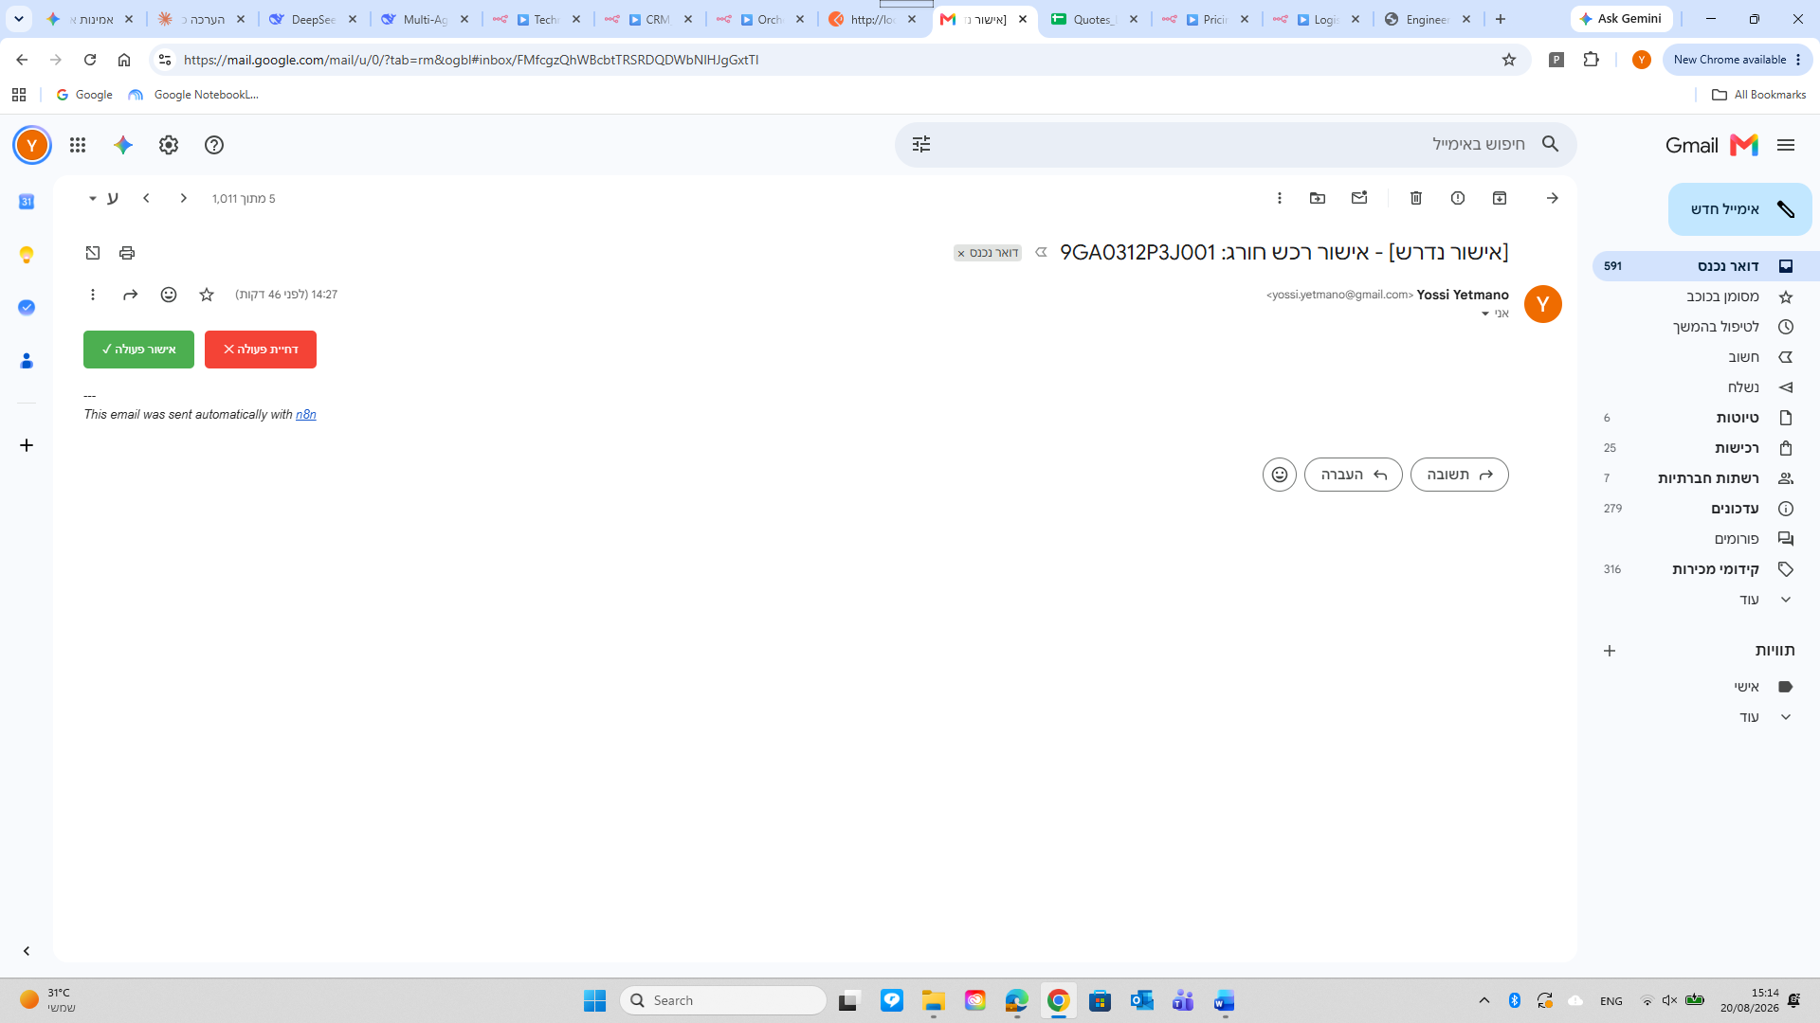Displays email with "Approve Action" and "Reject Action" buttons for Part #9GA0312P3J001
2. Manager Approval & Callback Processing:
Upon clicking "Approve Action", the callback webhook updates the session status to `APPROVED`. The Orchestrator immediately resumes the pipeline and routes the context to the Procurement Agent.
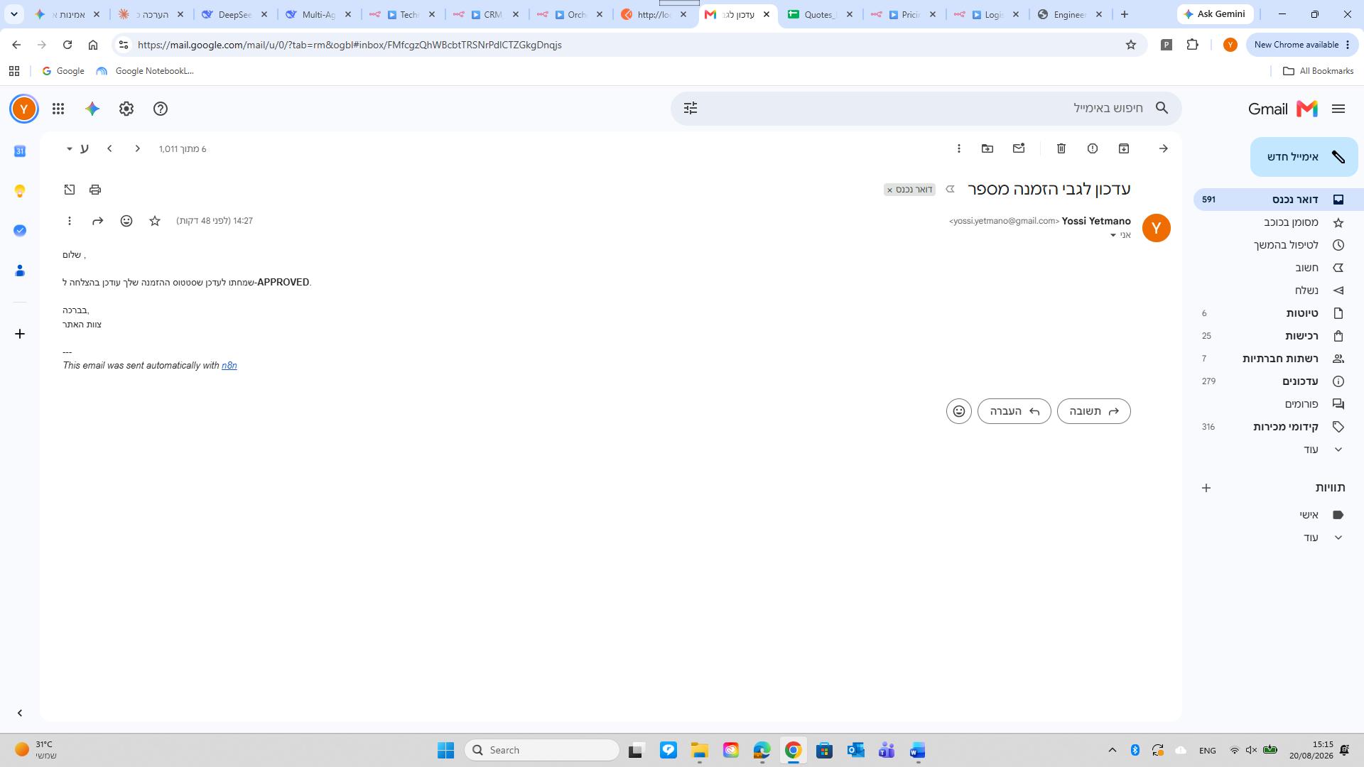Displays confirmation email: "APPROVED - Your order status has been updated successfully"
3. Procurement Agent (Supplier Purchase Order Generation):
The Procurement Agent generates an official Purchase Order (PO-2026-1343), logs the record to Google Sheets, and dispatches an official PO email to the supplier (Sanyo Denki) in USD ($448,906.25).
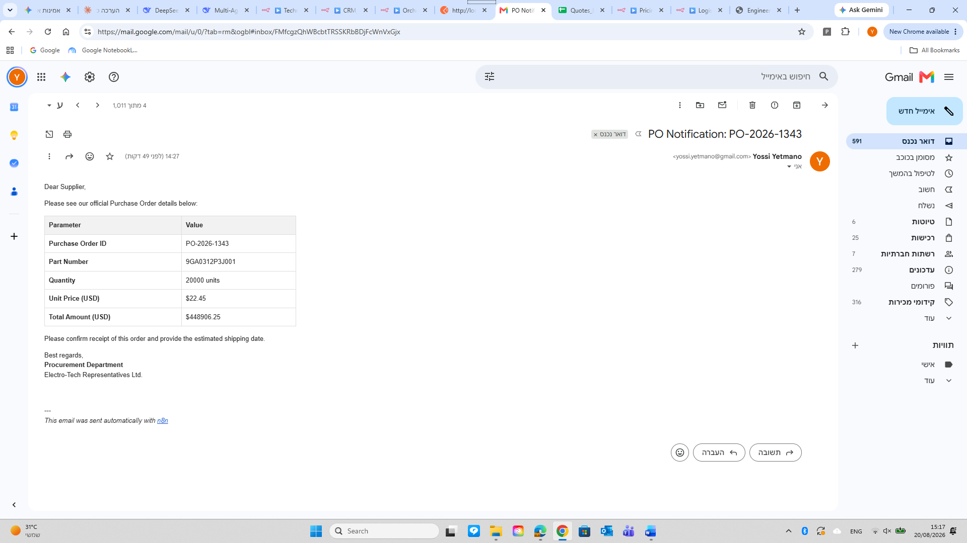Displays PO notification table sent to supplier Sanyo Denki for 20,000 units totaling $448,906.25 USD
4. Logistics & Finance Agents (Inventory Update & Invoicing):
The Logistics Agent records the receipt of 20,000 units into the local warehouse and notifies the customer. The Finance Agent generates an official commercial tax invoice (INV-2026-017) for 1,616,062.50 ILS under Net 30 terms.
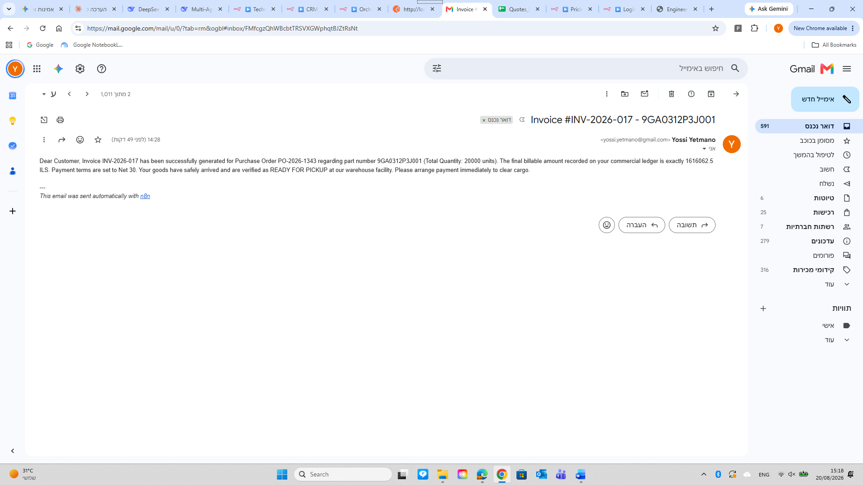Displays final tax invoice delivered to Soroka Medical for 1,616,062.50 ILS

Scenario B: Standard Purchase Order (PO) Within Credit Limit (Straight-Through Processing)
Fully Automated Flow - Zero Human Intervention Required
Input Payload Details:
* Customer: CUST-036 (Hadassah Medical Center)
* Part Number: 9GA0312P3G0011 | Quantity: 200 units
* Total Amount: 16,160.63 ILS ($4,490.00 USD) ← Within approved credit limit of 85,000 ILS
* Synchronous Quote ID: Q-2026-1327 | Session ID: SESS-1787225049508
Execution Steps & Evidence Screenshots:
1. Complete Orchestrator Pipeline Execution:
The Orchestrator sequentially processes the payload across all 9 agents without triggering HITL pauses. All nodes resolve with successful green execution state.
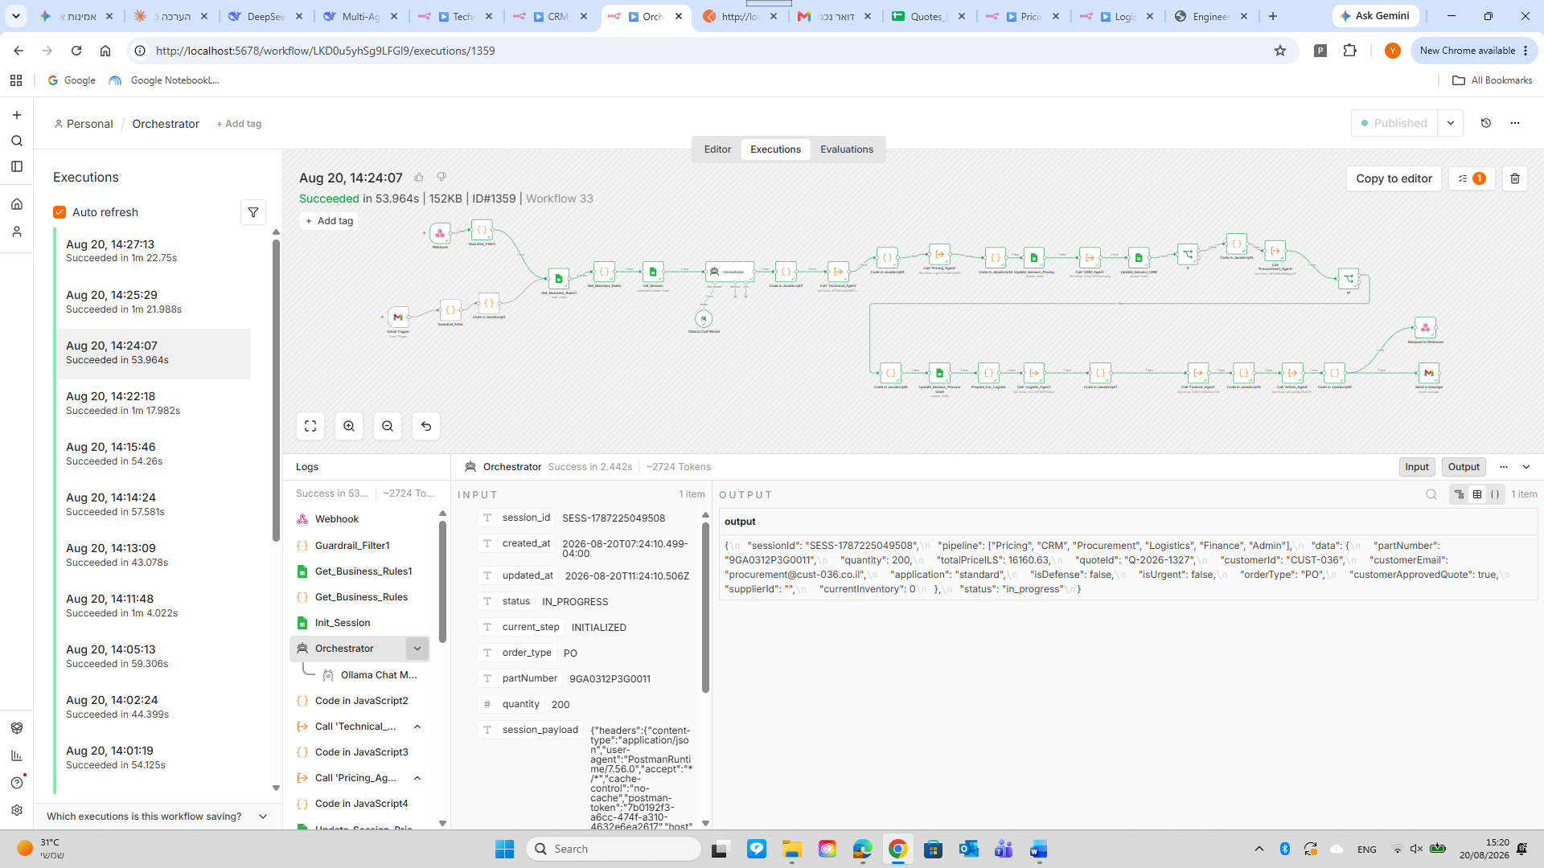Displays full green execution graph completed in 53.9 seconds end-to-end
2. CRM Agent & Procurement Agent Executions:
Automated credit clearance (`Within Credit Limit`) followed by immediate PO issuance (PO-2026-1327) totaling $4,490.00 USD.
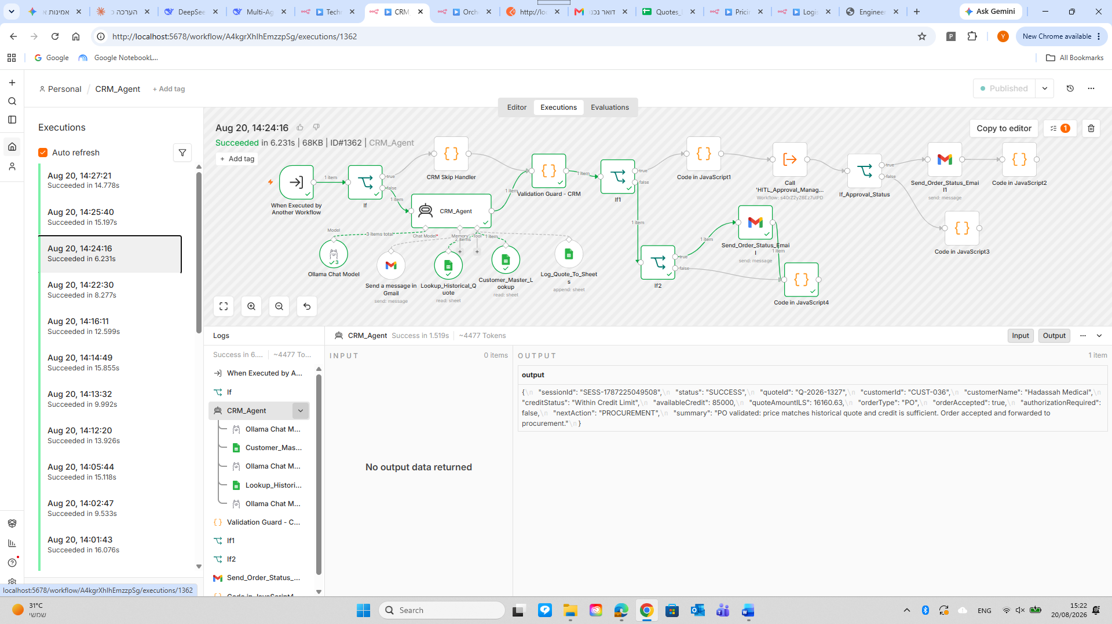Displays JSON output: `poid: PO-2026-1327`, `unitCostUSD: 22.45`, `totalCostUSD: 4490.00`
3. Pipeline Completion & Summary Email:
The Orchestrator concludes the session and sends a structured automation summary email to system administration.
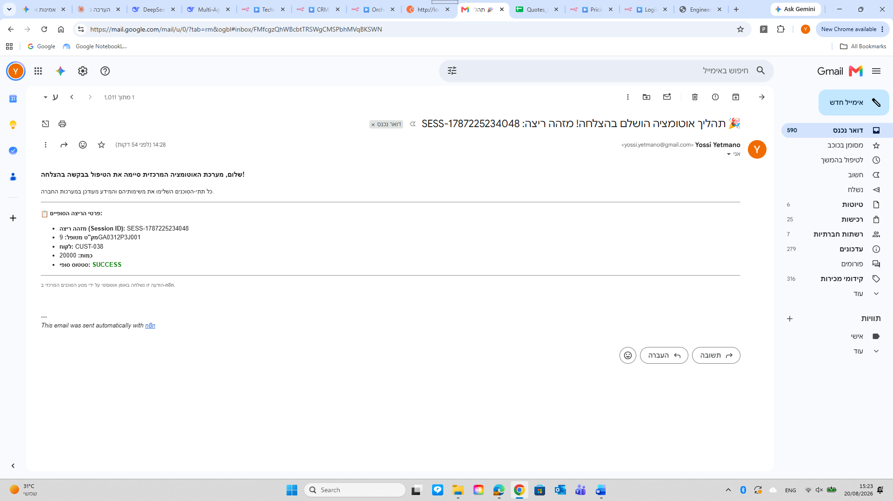Displays completion email: "Automation process completed successfully! Session ID: SESS-1787225049508"

Scenario C: Request for Quote (RFQ) & Official Quotation Issuance
RFQ Path - Evaluated by Technical & Pricing, Finalized at CRM, Skipped downstream
Input Payload Details:
* Message Type: RFQ (Request for Quote) | Session ID: SESS-1767224548101
* Customer: CUST-038 (Soroka Medical)
* Requested Part Number: 9GA0312P3J001 (DC Axial Fan 38x28mm 12V Pulse Sensor & PWM)
* Requested Quantity: 20,000 units
Execution Steps & Agent Breakdown:
1. Technical Agent Execution (RAG & Pinecone Vector Store Retrieval):
The Technical Agent verifies the part against the Pinecone Vector Store, confirming technical specs: "DC axial cooling fan with dimensions 38x28mm, operating at 12V with PWM control". Status set to `APPROVED`.
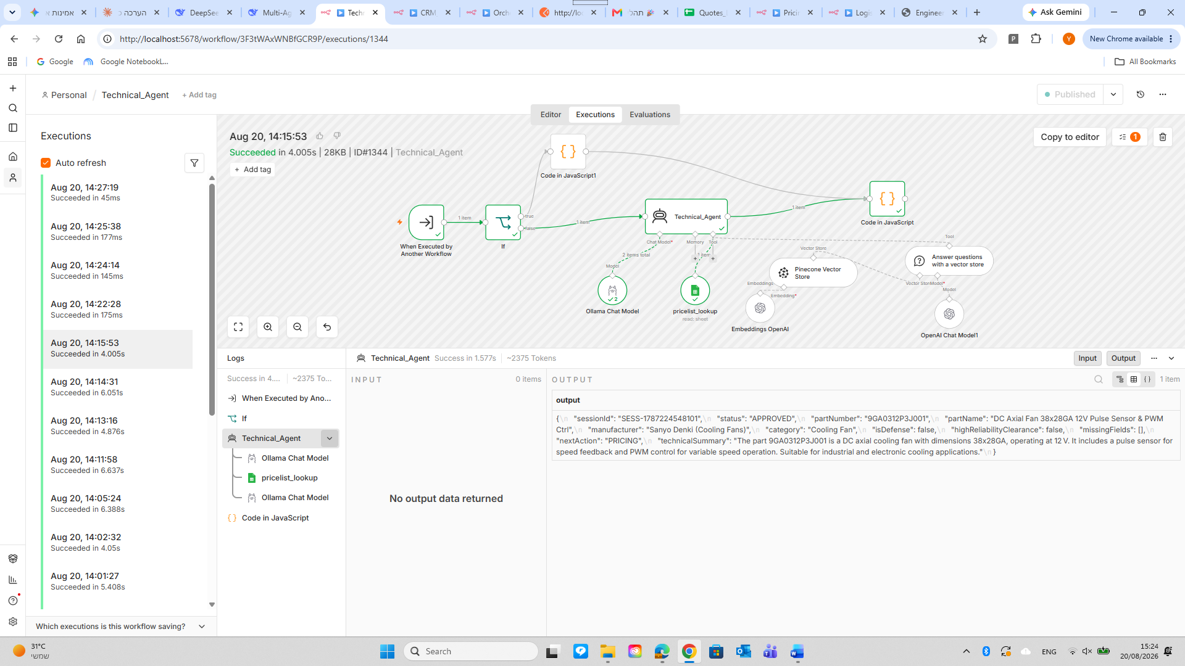Displays vector retrieval output and `APPROVED` technical status for 9GA0312P3J001
2. Pricing Agent Execution (Dynamic Price Matrix & Currency API):
Retrieves base price ($19.50/unit), applies a 15% tier volume discount for 20,000 units ($22.45/unit final cost), fetches real-time USD/ILS exchange rate via API, and calculates total: 1,616,062.50 ILS.
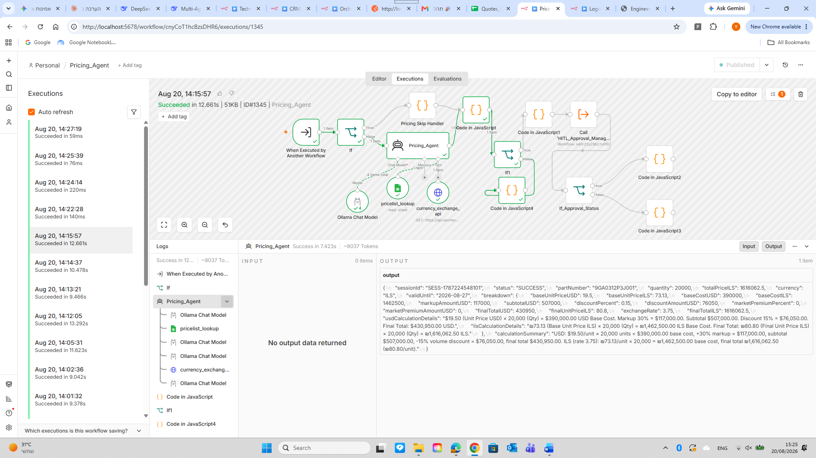Displays pricing breakdown: Base $19.50, Discount 15%, Exchange Rate, Final ILS: 1,616,062.50
3. CRM Agent & Formal Quote Email Issuance:
Generates official Quote ID (Q-2026-1343), records entry in `Quotes_Log`, and dispatches formatted quotation email to customer. Sets `nextAction: PROCUREMENT_SKIP`.
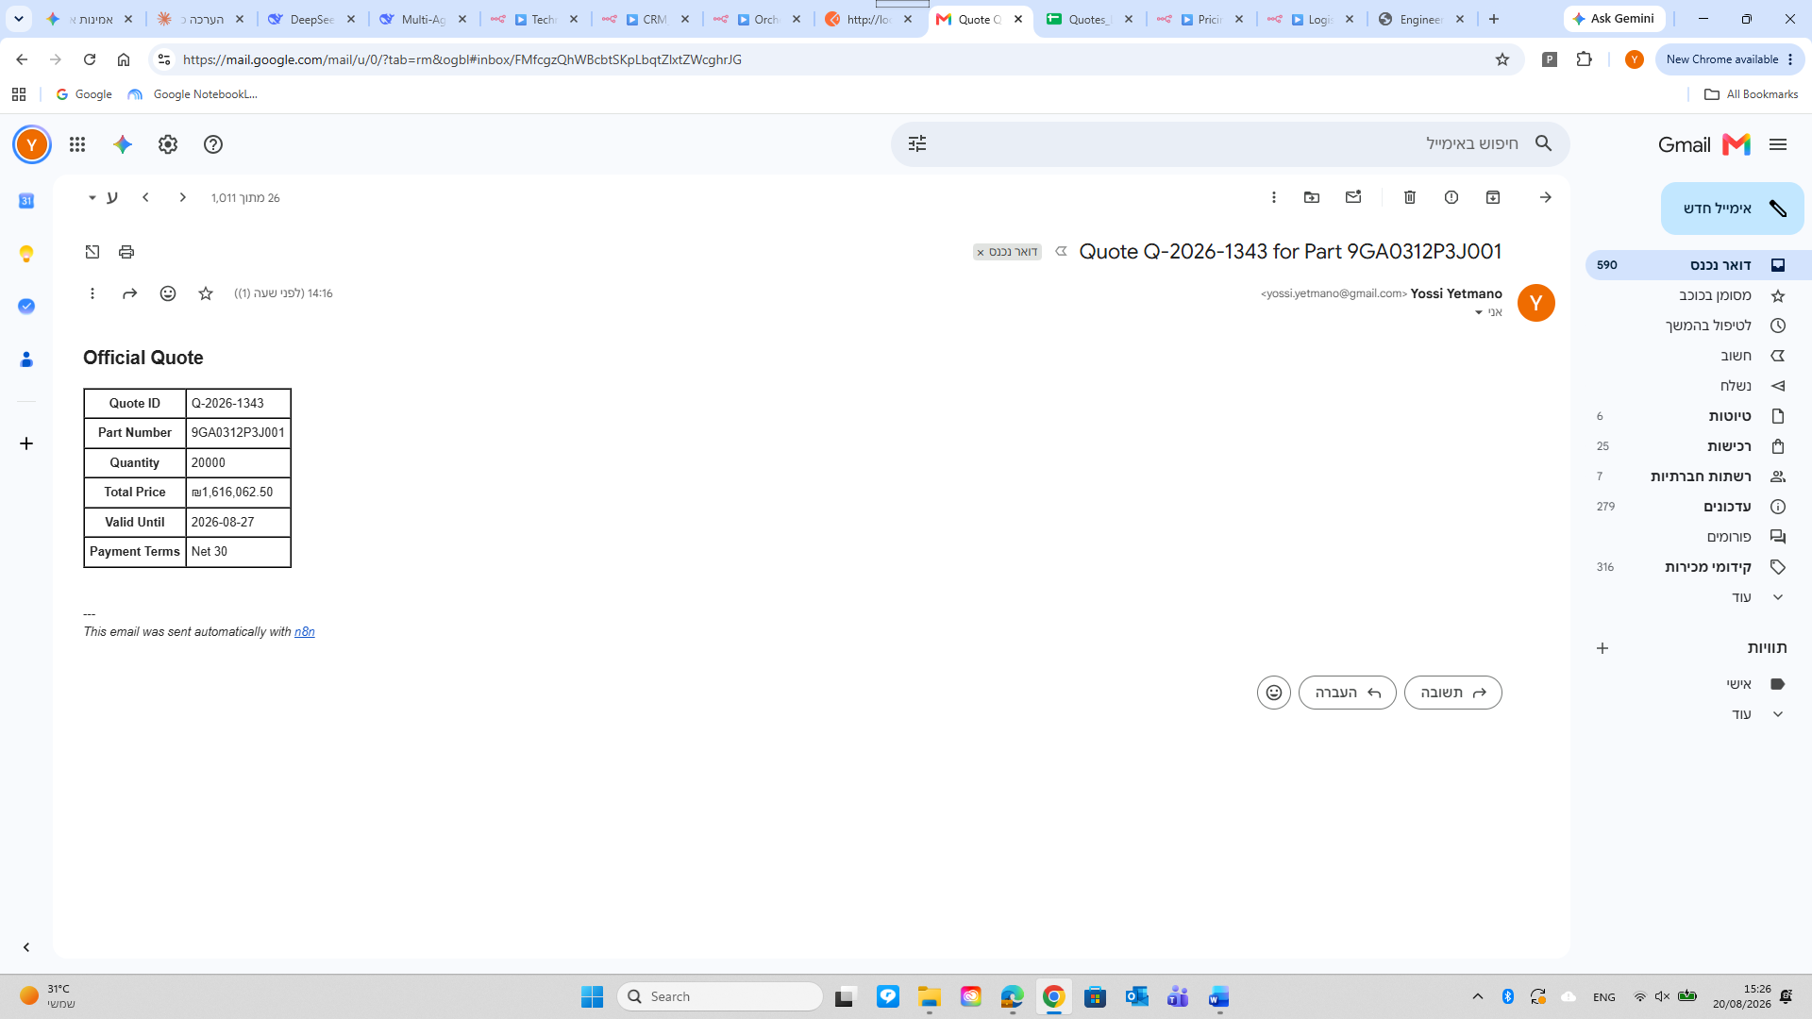Displays client quote email: "Quote Q-2026-1343 for Part 9GA0312P3J001" with itemized pricing table
4. Skip Handlers (Procurement, Logistics, Finance):
Procurement, Logistics, and Finance agents detect the RFQ context via their Skip Control Nodes, bypassing execution with zero side effects (no PO issued, no stock altered, no invoice generated).
Execution Metric | Scenario A (PO - Credit HITL) | Scenario B (PO - Automated STP) | Scenario C (RFQ - Quotation)
Session ID | SESS-1767225234048 | SESS-1787225049508 | SESS-1767224548101
Primary Document ID | PO-2026-1343 | PO-2026-1327 | Q-2026-1343
Active Agents | All 9 Agents | All 9 Agents | Technical → Pricing → CRM (Rest Skipped)
Credit Clearance | Exceeded (Manager Approved) | Auto-Cleared (Within Limit) | Cleared for Quote Only
Delivered Artefact | Invoice INV-2026-017 + Supplier PO | Invoice INV-2026-017 + Supplier PO | Client Quotation Q-2026-1343
Total Execution Time | 1m 22s (incl. Human Action) | 53.9s | 28.5s
Capstone Project Portfolio | AI Workforce Architect Certification | Yossi Yetmano © 2026

